FUNdraising Activities

 | BABY PICTURE MATCH GAME | Invite employees to try their luck at matching baby pictures of employees. Charge employees $2 per ballot to participate. Give a prize to the person that gets the most right answers.
BAGGIN IT | Designate a day as "Brown Bag Day". On that day encourage staff to bring their lunches and donate the money that they would ordinarily spend on going out to lunch to he State Combined Campaign. | 
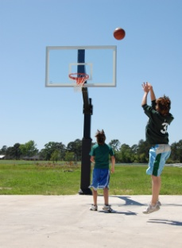 | BASKETBALL SHOOTING CONTEST | Set up a basketball hoop outdoors and have employees pay a dollar to see who can sink the most free throws. The money goes to he State Combined Campaign and the winner gets a cool prize. Consider having a waste basket version indoors.
BINGO | Sell bingo cards to employees and schedule a game. In place of traditional bingo, consider eBingo. Set an amount for each participant to pay to play. Send e-mails sporadically throughout the week with one or two Bingo numbers each time. Use donated prizes for the winners for either version. | 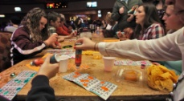
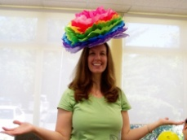 | CASUAL DAY | Sell Casual Day passes to employees to allow them to dress casually for a day for each pass purchased. You can also have a “Spirit Week” theme. For example, instead of just jeans, try Silly Hat Day, Outrageous Sock Day, or Sports Team Day.
CHILI COOK-OFF | Employees cook their favorite chili. Organize a panel of "expert" judges to decide on the best recipe. Charge employees to eat lunch and to cast their vote for the best chili. | 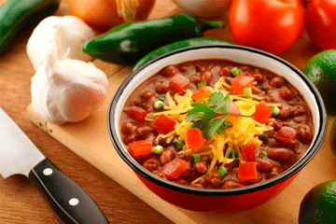
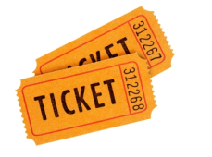 | HALF & HALF | Employees buy a ticket for a dollar. At the end of the day a ticket is drawn and that employee receives half the funds and the State Combined Campaign receives the other half.
ICE CREAM SOCIAL | Set up an ice cream bar with a variety of favorite toppings. Charge employees by the scoop. | 
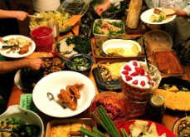 | POTLUCK PAYOFF | Organize a potluck lunch and have everyone bring a favorite dish. Charge employees to have lunch.
Wii TOURNAMENT | Pit employees against each other in a Wii tournament. Charge $5 entrance fee. Contestants can sign up for Wii sports- bowling, tennis, boxing, golf and baseball, or any other game/s you may have available. Have employees compete against each other head to head with the winner advancing up one bracket. Winner in each event can win a prize. Observers can place $1 bets on who will take each sport category.

