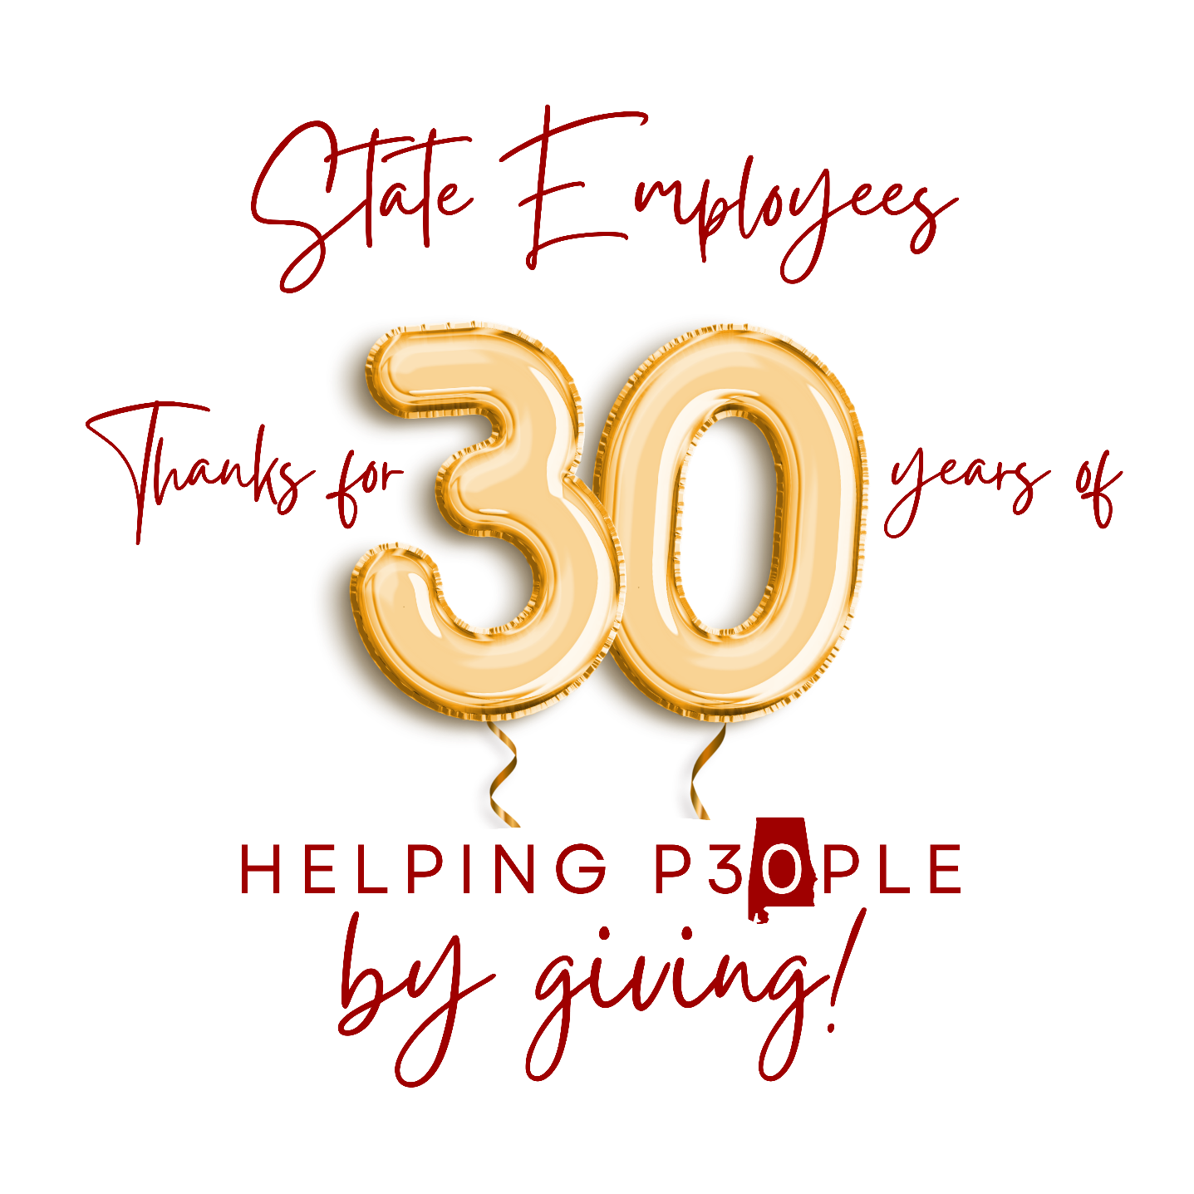

Coordinator and Keyworker Toolkit

TABLE OF CONTENTS

Thank You 3
2023 LARC Campaign Managers 4
Brief Overview of the SCC 5
Coordinator and Keyworker Responsibilities 6
8 Steps to Success… 7
Tips for Solicitations 9
How to fill out your Pledge Form 12
Group Solicitation 13
Tips to Remember 14
Campaign Planning Checklist 15
Sample Email from Coordinator or Department Head 17
Sample Letter from Director or Commissioner 18
Donor Reward Card Listing 19
Request for a Speaker 20
2023 State Combined Campaign Goals 21

Thank you!
Thank you for serving as a volunteer for the State Combined Campaign. You are the most important part of this annual fund-raising effort.

Your support and enthusiasm will be essential to inspiring others to participate so we may make life a little brighter for many of those less fortunate.

Through your eyes, your fellow employees will see the value of the agencies supported, as well as the people who receive help.

This training will help you accomplish this most important mission. Thank you for being a volunteer in this year’s campaign.

Remember, every person and every dollar makes a difference!

A Word about Payroll Deduction

All state employees are eligible to make contributions to the State Combined Campaign through payroll deduction.

Since payroll deduction has been made available, a growing number of employees have taken advantage of this easy way of giving. This has resulted in an increase in contributions.

Payroll deduction allows state employees to give a little every month. By spreading the gift over the entire year, a small monthly gift can result in a large annual donation.

Explain it this way: “It’s a gift you’ll never miss, that someone else will never forget.”
Contact Info
State Combined Campaign
8 Commerce Street, Suite 1140, Montgomery, AL 36104
phone: 334. 269.4505 fax: 334.269.4410

website: www.statecombinedcampaign.org

Staff:

Becky Wilburn Booker, Executive Director Email: bbooker@unitedwaysal.org

Sharilyn Hamer, Office Manager/Campaign Associate Email: shamer@unitedwaysal.org

Kathy Beatty, Campaign Associate Email: kbeatty@unitedwaysal.org

LARC Campaign Managers

LARC 1 – Northwest Alabama (Colbert, Franklin, Lauderdale, Marion)
Ms. Laura Columbus (256) Email: Laura@uwshoals.org
United Way of Northwest Alabama, 205 West College Street, Florence, AL 35631
LARC 2 – North Central Alabama (Lawrence, Morgan, Winston)
Ms. Brooke Rawlins (256) 686-3405 Email: brawlins@uwmcal.org
United Way of Morgan Co, 115 1st Avenue NE , PO Box 1058, Decatur, AL 35602
LARC 3 – Jackson & Madison Counties
Ms. Sherry Pentecost (256) 616-4042 (C) (256) 518-8210 (O) sherry.pentecost@uwmadisoncounty.org
United Way of Madison Co, 701 Andrew Jackson Way NE, Huntsville, AL 35801
LARC 4 – West Alabama (Bibb, Fayette, Greene, Hale, Lamar, Marengo, Pickens, Sumter, Tuscaloosa)
Ms. Monique Scott (205) 345-6640 Email: monique@uwwa.org
United Way of West Alabama, PO Box 2291, Tuscaloosa, AL 35403-2291
LARC 5 – Central Alabama (Blount, Chilton, Jefferson, Shelby, St. Clair, Walker)
Ms. Brandi Fleming (205) 458-2030 Email: brandi.fleming@uwca.org
United Way of Central Alabama, 3600 8th Avenue South Birmingham, AL 35222
LARC 6 – Etowah County
Ms. Liz Benninger (205) 800-9604 Email: lbenninger@uwoec.org
United Way of Etowah County, 235 College Street, Gadsden, Alabama 35901
LARC 8 – East Central Alabama (Calhoun, Clay, Cleburne, DeKalb, Randolph, Talladega)
Ms. Angie McVeigh (256) 236-8229 Ext. 114 Email: amcveigh@uweca.org
United Way of East Central Alabama, PO Box 1122 or 1505 Wilmer Avenue, Anniston, AL 36201
LARC 10 – Statewide & South Central Alabama (Autauga, Bullock, Butler, Chambers, Coosa, Crenshaw, Dallas, Elmore, Lee, Lowndes, Macon, Marengo, Montgomery, Perry, Pike, Russell, Tallapoosa, and Wilcox Cos.)
Ms. Becky Booker (334) 694-7011 Email: bbooker@unitedwaysal.org
Ms. Sharilyn Hamer (334) 694-7012 Email: shamer@unitedwaysal.org
United Ways of Alabama, 8 Commerce Street, Suite 1140, Montgomery, AL 36104
LARC 11- Southwest Alabama (Baldwin, Choctaw, Clarke, Conecuh, Escambia, Mobile, Monroe, Washington)
Ms. Leslie Schraeder (251) 431-0101 Email: lschraeder@uwswa.org
United Way of Southwest Alabama, 218 Saint Francis Street, Mobile, AL 36602
LARC 12 – Wiregrass Area (Barbour, Coffee, Covington, Dale, Geneva, Henry, Houston)
Ms. Angie Sherrill (334) 792-9661 Email: finance@wuw.org
Wiregrass United Way, 304 North Foster Street, Dothan, AL 36303
Brief Overview of the SCC

In 1991, the Alabama Legislature enacted the Alabama State Employee Combined Charitable Campaign (Act No. 91-561) providing Alabama state employees the opportunity to contribute to a multitude of charities through the convenience of payroll deduction. This single convenient channel allows state employees to support their charity of choice while minimizing workplace disruption and administrative cost to Alabama taxpayers.

The State Combined Campaign, or SCC, is a once-a-year, on-the-job charitable solicitation of state employees. The campaign permits state employees to give monetary support to qualified human health, welfare and human care service charities recognized by the Internal Revenue Service under 26U.S.C.501(c)(3).

The SCC is the only authorized payroll deduction charitable fundraising effort for state employees. The SCC supports the work of approved charitable agencies and organizations. These agencies fight disease, make life more meaningful for the young and aged, assist the impoverished, and help people become economically self-sufficient.

Oversight of the campaign is provided by a Steering Committee composed of a Chair, appointed by the Governor, and six other members representing all three branches of state government. Local organization and administration are accomplished through 10 Local Agency Review Committees (LARCs) comprised of state employees throughout Alabama. Local Campaign Managers support LARCs. This ensures local input from agency review to distribution of funds and other campaign procedures.

The Law permits the use of time during the workday throughout the campaign period for volunteers to participate in the SCC, with the approval of the department head.

The Statewide Campaign Manager’s office remits designated agency contributions to the appropriate organizations. Undesignated funds are distributed among the participating agencies in the same percentage as designated funds.

The Campaign Coordinator and Keyworker Responsibilities
The Campaign Coordinator is a very important position which provides leadership, direction, and enthusiasm for your organization’s campaign. The Keyworker role mirrors the Coordinator role at a Division or Section level. Primary responsibilities are outlined below.

Responsibilities Prior to the Campaign:
• Create a winning team by recruiting others to help make your campaign a success.
• Attend Coordinator Training.
• Develop your plan, including budget, theme, and events to support your campaign.
• Establish a campaign timeline.
• Communicate with your local SCC Campaign Manager regarding your strategies to meet your goals.

Responsibilities During the Campaign:
• Consult with your SCC Campaign Manager/Statewide Campaign Manager to receive guidance and all necessary materials for your campaign.
• Conduct Leadership Campaign to include events or face to face (may be virtual) solicitation as needed.
• Campaign Kick-off & special events may look very different – think outside of the box.
• Hold employee meetings (in-person or virtually); tell the SCC story, show available videos, and ask for pledge.
• Make sure everyone is offered the opportunity to give, fills out form correctly and turns it in.

Responsibilities After the Campaign:
• Make sure all pledge information is reported completely and correctly to SCC Statewide Campaign Manager (SCC SCM)
• Turn in campaign results to SCC SCM accurately & promptly.
• Implement THANK YOU portion of campaign.
• Organize information for next year’s campaign team.

SCC SCM will offer additional training sessions for Keyworkers. The meetings will be virtually offering insight into the 2023 Campaign and for ideas sharing. Contact SCC SCM office for additional details.

8 Steps to Success

STEP #1: GET STARTED
Attend a State Combined Campaign’s Campaign Coordinator training.
- Learn the importance of State Combined Campaign
- Review State Combined Campaign materials
- Call/Meet with your State Combined Campaign representative (State Combined Campaign Manager and/or Loaned Executive)

STEP #2 ENLIST SOME HELP
This task is much easier and more fun when you involve others.
- Ask your Commissioner/Director to support the recruitment of Keyworkers to work with you.
- Recruit a Keyworkers representing all the divisions and/or sections in your organization.
- Your Commissioner’s/Director’s enthusiasm can be contagious. Ask him or her to write a personal letter/email of support to send to all employees.

STEP #3: ANALYZE CAMPAIGNS AND SET A GOAL
You will be assigned a goal by the SCC Campaign Manager based on your organization’s size and the overall statewide goal. Setting a realistic campaign goal can motivate and encourage participation. Talk with last year’s Campaign Coordinator. Find out what worked and what didn’t work during last year’s campaign. You can also talk with your State Combined Campaign representative who is a good resource during campaign analysis and goal setting.

Look at past results, keeping in mind:
- The number of contributors
- The total amount raised.
- The participation rate.
Based on what you find, consider setting goals for:
- Total dollars to raise.
- Percent of employee participation
- Average gift
STEP #4: DECIDE ON SOLICITATION STYLE (This may look different and can be virtual)
Decide on the best method of approaching fellow employees – group, individual or both.
- Group Solicitation: Employees are brought together to hear the State Combined Campaign message and are then asked to fill out their pledge forms at the end of the presentation. Group solicitation allows for efficient use of time, and because employees hear a uniform message, less follow-up is required.
- Individual Solicitation: This is a one-on-one ask to an employee for a gift. This style involves more employees but personalizes the campaign and offers you a greater opportunity to answer individual questions.
- Both: Hold one group meeting or a series of group meetings and use the one-on-one solicitation to follow-up with those who couldn’t attend a group session.

STEP #5: PROMOTE YOUR CAMPAIGN
By promoting your campaign, you will be encouraging others to get involved.
- Use employee newsletters, e-mail and other in-house communication tools – weekly.
- Use State Combined Campaign posters and brochures to build awareness of the upcoming campaign. If you need additional materials, please let the SCC Campaign Manager’s office know! (May be digital version that is emailed or on a web page.)
- Increase employee awareness by creating competition between departments. Prizes and incentives can also create interest. Talk to the SCC Campaign Manager to brainstorm on what might work in your organization.

STEP #6: EDUCATE
- Use agency video and virtual speakers to show how State Combined Campaign dollars are at work.
- Visit www.statecombinedcampaign.org for additional tools and information.
- Schedule your virtual speakers soon!

STEP #7: CONDUCT THE CAMPAIGN
Schedule a short, intensive campaign. Short campaigns keep the momentum and enthusiasm high. A shorter campaign has proven to be the most effective. The SCC officially ends on December 31st.

- Make a gift yourself. It is easier to ask others to give when you are giving.
- Use personalized pledge forms, when possible, to ensure everyone has an opportunity to contribute.
- Get help from payroll, data processing and department heads.
- Conduct an employee kickoff celebration.
- Use an agency video(s) in your meeting(s) to make employees aware of the services provided locally.
- Make sure every employee is asked to give. Don’t forget employees who work off-site, travel extensively, or are on alternate shifts.

STEP #8: REPORT RESULTS
It is very important to report the results to State Combined Campaign as soon as possible. For large departments/agencies weekly reports are recommended, with a final report following the completion of your campaign. Call your State Combined Campaign representative if you have questions.
- Weekly partial reports allow State Combined Campaign to cash personal checks in a timely fashion.
  - If you are using PDF pledge forms rather than paper forms, make sure there is a way for employees to send their checks into you or the bank verified receipt where they deposited it into the Regions or Renasant bank account.
- Make sure all pledge forms are returned and accounted for.
- Forward copies of all payroll deduction forms to your organization’s payroll department.
- Summarize all campaign information on the Report Envelope. Enclose cash, checks and copies (white and yellow) of all pledge forms.
- Remember to tell everyone “THANK YOU!”

TIPS FOR SOLICITATION
- Meet with your State Combined Campaign representative (State Combined Campaign staff or loaned executive) to review the details for your group meetings, including the agenda, speakers—both from inside and outside your organization—and the logistics. Be sure to include your Commissioner/Director or other senior organization executive on the agenda.
- Choose an appropriate meeting time. Publicize group meetings well in advance and send reminders to employees. Remember to use your organization’s established communication channels.
- Use the State Combined Campaign Talking Points (available from your State Combined Campaign representative) to help with basic information.
- Use incentives to encourage employees to get involved. Food and door prizes are great for getting people to come to meetings and time off is a great incentive for gift giving.

NO COST/LOW-COST INCENTIVES
- The #1 incentive is(are) casual day(s). Discuss options with Commissioner/Director.
- You can solicit local businesses for items for the State Combined Campaign. Ask the State Combined Campaign Statewide Manager how.
- The State Combined Campaign has a limited supply of no cost items.
- Ask other employees to donate items or services to give away.
- Kickoff Event. A kickoff event is a terrific way to announce the start of your campaign and to generate enthusiasm. Have a speaker from a local charity. Ask your agency head to host the event. Have the management team attend and make their donation. Can be in-person or virtual.
- Prize Drawings. Hold drawings during your campaign to encourage employees to turn in their pledge cards.

VIRTUAL FUNDRAISING
- What is a virtual event?
- An online event with attendees that connect remotely from wherever they are, instead of gathering in person. These types of events can also take place over the course of a few days, rather than on a single day, which can make them much more convenient for your supporters. Can be hybrid model.
- How to host an online event or virtual fundraiser? Two things:
  - A well-branded campaign page that includes information about the event where supporters can fundraise, donate and interact.
  - A great communications strategy that drives traffic to your campaign page and keeps supporters engaged throughout the event. (KEY POINT)

BENEFITS OF VIRTUAL FUNDRAISING:
- Audience reach-You can expand your audience beyond only people who can attend your events in person and participation can be greater than in-person events. (anyone can participate from anywhere, at any time & at their convenience)
- Planning-Online events are easy to plan and execute, because they aren’t as logistically complex as physical events.
- Cost Effective-Because there’s very little overhead, virtual events are cost-effective compared to live fundraising events.
- Online Experiences- Technology like video chat and messaging makes it possible for attendees to feel connected, even when they’re not together.
- Event Feedback-easier to track who participated and the outcome.

SUCCESSFUL VIRTUAL EVENT PLANNING
Customize your campaign story to highlight that the event is virtual.
- Promote your event as a virtual event so it’s clear to all participants.
- Add video to your campaign to keep participants engaged.
- Add a campaign goal to create fundraising momentum and track progress.
- Add offline donations so all supporters feel included and appreciated.

EVENT IDEAS:
- BINGO | Sell bingo cards to employees and schedule a game. In place of traditional bingo, consider eBingo. Set an amount for each participant to pay to play. Send e-mails sporadically throughout the week with one or two Bingo numbers each time. Use donated prizes for the winners for either version.
- CASUAL DAY FUNDRAISER | You’d be amazed by the lengths folks bound to a professional dress code will go to just for the chance to ditch their slacks and wear jeans to the office. Sell Casual Day passes to employees to allow them to dress casually for a day for each pass purchased. You can also have a “Spirit Week” theme. For example, instead of just jeans, try Silly Hat Day, Outrageous Sock Day, or Sports Team Day.
- PARKING SPOT FUNDRAISER |Much like the privilege of wearing jeans to work, many employees will do pretty much anything under the sun for a prime parking spot. Finding a nice parking spot in the shade that’s close to the door is the true Holy Grail.
- ONLINE AUCTION-LIVE OR SILENT | gift card auctions, donations from businesses, etc.
- FOOD DRIVE | Have everyone turn in a pledge form with a donation to a local food pantry instead of a can of food. A food bank can purchase at least $5 of food for every $1 donation.
- CONFERENCE CALL COSTUME CONTEST | Costume will be from neck up – award prizes accordingly (funniest, silliest, unique, etc.)
- GREAT OFFICE BAKE-OFF | Like the chili cook off, but with baked goods!
- SCAVENGER HUNT | Ask people to go on a scavenger hunt in their area by finding items or completing challenges that can be done anywhere: take a photo with a stranger, find a specific type of car, or locate random objects around their neighborhood or in a park. This can be a family fun event while socially distancing.
Remember…
- Special Events can be time-consuming, so whenever possible, ask for help from your colleagues and keyworkers. Delegate specific tasks to be completed by a certain time, and always remember to thank volunteers for their time and energy!
- Special SCC fundraising events, such as auctions, bake sales, carnivals, athletic events, or other activities are permitted during the campaign period if approved by the appropriate agency head or government official and are consistent with the agency’s ethics regulations. In all approved special fundraising events, the donor may have the option of designating to a specific participating organization or federation or be advised that the donation will be counted as an undesignated contribution and distributed according to the regulations.
- Remember to consider the rules for SCC Special Events (is it legal?). Games of chance are not allowed – that is generally considered a type of gambling. Sweepstakes (no purchase necessary) are allowed. Games of skill are always encouraged (i.e., tournaments, guess the quantity in the jar, Golf Scrambles, etc.). If you have any questions, please call the SCC Manager’s office at 334-269-4505!

The staff at SCC will be happy to help you coordinate and plan any event.

HOW SHOULD I USE INCENTIVES?
The important thing is to use incentives as a tool to increase participation or increase the average gift of your employees, not to coerce employees to give.

STRATEGIES TO INCREASE PARTICIPATION
- Use incentives for first time donors.
- Everyone who contributes via payroll deduction is entered in a drawing. When the campaign is complete, have the drawing for incentives.
- If you make the company goal, throw a party.
- Hold a drawing for all employees who go on a tour of a State Combined Campaign agency.

STRATEGIES TO INCREASE THE AVERAGE GIFT
- Use incentives for donors increasing their annual gift.
- Give the employees extra time off to increase their gift by 10%.
- Hold a leadership giving campaign.
- Establish a company leadership level and recognize accordingly.
- Use “Examples of What Your Gift Can Achieve” information.
- Ask employees to give $1 more a week.
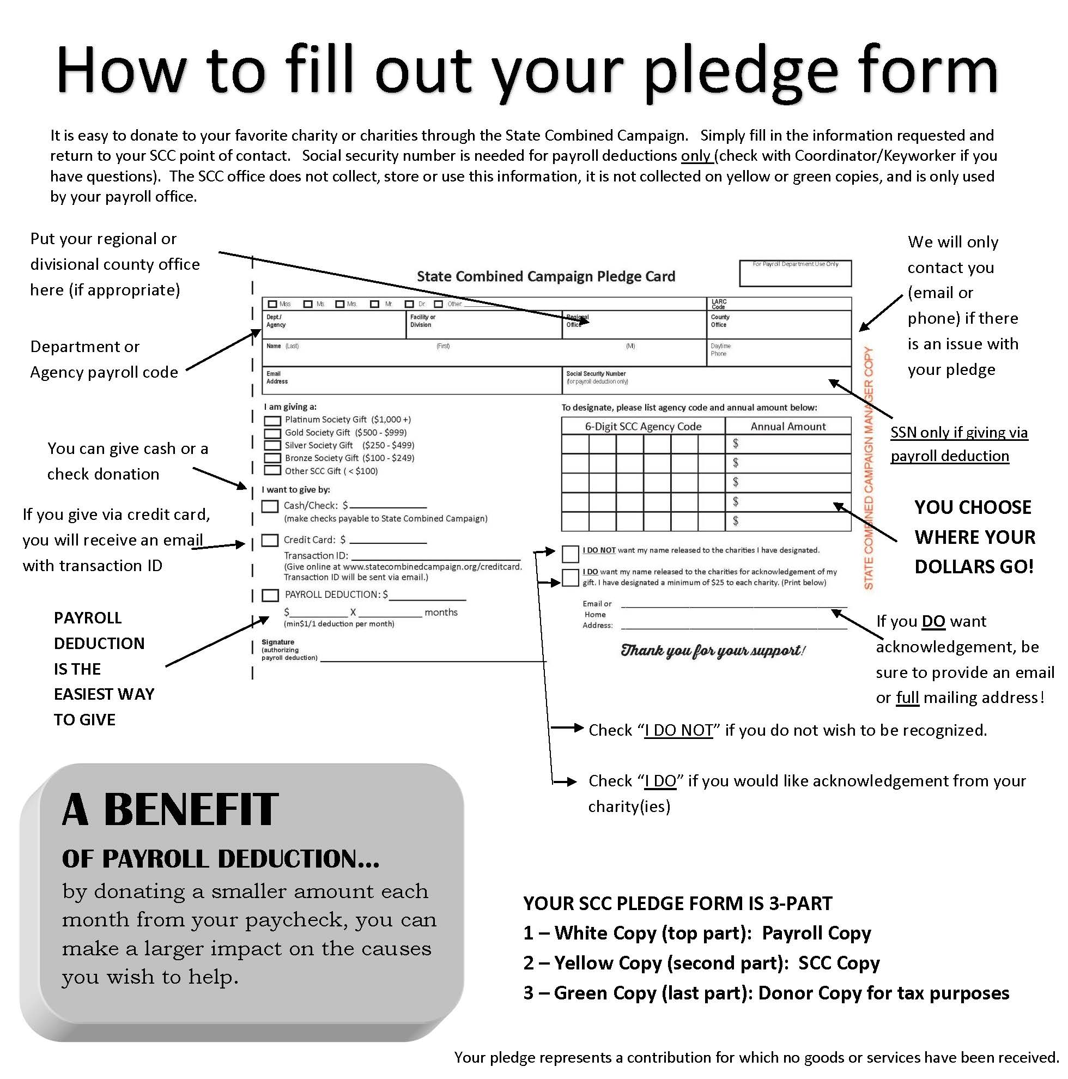

Group Solicitation

The 15-Minute Package

The sequence of events for group solicitation can be effectively accomplished in about 15 minutes and can be modified to fit the activity and circumstances.

Here’s how:

Be Prepared
Make sure the details are taken care of, such as an advanced announcement and publicity; guest speaker confirmed and briefed; video equipment set up and checked; all materials on hand.

Welcome/Coordinator Opening Remarks (2 minutes)
Campaign Coordinator distributes Giving Guide and pledge forms to all employees at the beginning. Provide pens to anyone who does not have one. Be personal, sincere and brief. State purpose clearly and simply.

Campaign Endorsement (Agency Head or Commissioner – 2 minutes)
Makes statement of support; relates any personal experience; identifies campaign objective.

Guest Speaker or Agency Video (Agency or Federation representative or video– 4 minutes)

Employee Testimonial (4 minutes)
An employee from your agency or another state agency shares his/her personal experience with a non-profit agency listed in the Campaign Guide.

Campaign Review and Closing (3 minutes)
Coordinator answers questions and provides information about the campaign and where to return pledge cards. Thanks everyone for attending.

♦♦♦

Individual Solicitation

Those who do not give in the group solicitation can be followed-up by coordinators for a later, tactful one-on-one attempt. A one-on-one approach can be used for anyone who did not attend the group solicitation. Be considerate of your potential donor when making your approach. Timing is important. Don’t interrupt or attempt solicitation at an inconvenient time. Make it a positive approach and a positive appeal. After you are done, simply ask the employee to complete their pledge form. If the answer is “no,” don’t argue or pressure. Simply thank them for their time and let them know if they change their mind, you’ll be available.

Tips to Remember:

participate in the training sessions, agency tours (when available), and the Kick-off.

personally, invite people to participate. Technology is a useful tool, but it doesn’t substitute personal contact. The best campaigns are both high-tech and high touch.

take a positive approach.

listen, encourage questions, and answer all questions. When you need help, contact your statewide coordinator, Local Campaign Manager or call the Statewide Campaign Manager’s office at 334.269.4505.

ask for an increase in the pledge amount – even if it is only $1.00 because every dollar
makes a difference.

turn in ALL pledge cards, checks, and cash promptly to your statewide coordinator.

ask everyone to make a decision, even though the decision to give is always voluntary. Remember that pledge cards and pledge amounts are personal and confidential.

Please don’t:

forget to respond to anyone who asked a question. If you accidentally forget to do so immediately, remember an answer is still important.

leave someone’s pledge card on their desk or ask for their contributions over the phone, by memo, or email.

approach people without notice, when they’re obviously busy, or under pressure to make a deadline.

ever pressure anyone to give but do make a sincere effort to demonstrate the positive impact SCC contributions have on people who need help.

forget to say, “Thank You!”. Thank everyone – every person you ask – regardless of whether they contribute to the SCC, thank them for their time and consideration.

Campaign Planning Checklist |  | Team Member Responsible |  | Target Date | Activity  Complete

Before Campaign

- Recruit a diverse Campaign Team
- Learn about the State Combined Campaign
at a Coordinator Training
- Meet with SCC staff / representative
- Train your Campaign Team/ Set up other planning meetings
- Review past campaign results
- Determine areas of potential
- Identify strengths and weaknesses
- Determine campaign needs (prizes, budget, etc.)
- Develop a plan based on Campaign Analysis
- Meet with Commissioner/Director for support/approval & request for visibility & support during the Campaign
- Review/Set the Goal
- Establish a campaign timeline
- Schedule agency speakers (and tours)
- Create special themes and fun-filled events
- Launch a PR campaign to communicate with employees
- Personalize the pledge cards if possible
- Send Dept. Head endorsement letters
Campaign Planning Checklist | Team Member Responsible |  |  | Target Date | Activity  Complete

During Campaign

- Conduct Leadership Solicitation (meeting or face to face)
- Keyworker Training (for large departments)
- Campaign Kick-off & special events
- Hold employee meetings/tell the SCC story & make the ask
- Conduct one-on-one solicitations
- ALL PLEDGE CARDS TURNED IN
 | Team Member Responsible |  |  | Target Date | Activity  Complete

After Campaign

- Ensure all pledge forms have been gathered, accounted for and have been turned-in to the SCC office for processing
- Give Payroll Deduct set of copies to payroll dept.
- Verify totals match with SCC office totals
- Implement THANK YOU campaign
- Organize information for next year’s campaign team
- Attend the SCC wrap-up celebration
- Lessons learned

Email from Coordinator or Department Head

Dear [name]:

The 2023 State Combined Campaign (SCC) kicks off in our department/agency today! This is the 30th anniversary of the SCC and over the past 30 years, State Employees have collectively given more than $20 Million dollars to our favorite charities. We are excited to get started because at [name of agency or department], we recognize that when you reach out a hand to one, you influence the condition of all.

Last year, we raised [$XX,XXX] for our communities and we hope to surpass that number this year. During the next few weeks, you will get an opportunity to learn more about how SCC charities provide others with the services needed for a quality life.

The past few years have been challenging for so many Alabamians. COVID and now high inflation are impacting so many… many have lost jobs, and businesses that once thrived, are struggling to keep the doors open. We are so lucky as State Employees that our livelihoods were not affected; that we have been able to continue working and to continue to provide for our families. We are indeed blessed.

You will also receive a pledge form and campaign brochure with more information. Please return your pledge form to me by [date]. You may want to acknowledge attachment here if using digital materials.
Everyone can share something, so please join me in making a gift to the SCC this year. Together, we can make a difference! We can reach our goal and help Alabamians from all walks of life, from the Shoals in North Alabama to the sandy beaches in South Alabama – and everywhere in between! We can do it because Alabama’s State Employees have been helping people by giving!

Sincerely,

[Campaign Coordinator or Department Head]

M E M O R A N D U M

TO: All Employees

FROM:

DATE:

RE: 2023 State Combined Campaign

This year marks the 30th anniversary of the State Combined Campaign and this year’s campaign is underway. I feel this is a great and an easy way for State Employees to give to his/her favorite charity(ies). I encourage each of you to participate. This combined appeal is a very worthy cause, and it is because of your financial support that so many individuals and families with special needs are assisted in so many ways.

This year, _______________________ and __________________ are heading up the campaign for our department/agency and will be glad to answer any questions you may have, from where the money goes, to how to fill out the pledge cards. Remember, the easiest way to give is through payroll deduction, where you may give as little as $1 a month. You may also make a one-time donation by cash, check or credit card. Most importantly, you can designate which agency(ies) you want your money to go.

Many of us have experienced difficulties in our lives or may know someone who has benefited from one of these agencies. I encourage all of you, our family here at _____________, to be there for someone in their time of need by sharing your financial support to the State Combined Campaign. It is even more important to give this year because of the economic crisis so many are facing today.

I fully support this campaign and again I urge your participation. Your contribution to this campaign demonstrates your concern and care for others and I commend all of you in advance for your participation. Thank you!

For a gift of at least $36

Confirmed discount cards:
Baldwin County: Lana Mummah lmummah@unitedway-bc.org 251-943-2110
Central Alabama: Brandi Fleming brandi.fleming@uwca.org 205-458-2030
Cullman County: DeAnn McDonald dmcdonald@uwaycc.org 256-739-2948
East Central Alabama: Angie McVeigh amcveigh@uweca.org 256-236-8229 EX 114
Etowah County: Robyn Phillips campaigndirector@uwoec.org 256-547-2581
Lake Martin Area: Courtney Layfield courtney.layfield@unitedwaylakemartin.org 256-329-3600
Madison County: Sherry L. Pentecost sherry.pentecost@uwmadisoncounty.org 256-616-4042
Marshall County: Raquel Zavaleta raquel@unitedwaymarshall.org 256-582-4700
Mobile Area: Leslie Schraeder lschraeder@uwswa.org 251.431.0101
Montgomery Area: Sharilyn Hamer shamer@unitedwaysal.org 334-269-4505
Morgan County: Brooke Rawlins brawlins@uwmcal.org 256-686-3405
Tuscaloosa Area: Monique Scott mscott@uwwa.org 205-345-6640
Wiregrass Area: Angie Sherrill finance@wuw.org 334-792-9661

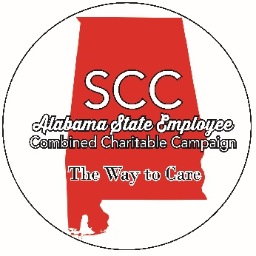
8 Commerce Street, Suite 1140
Montgomery, Alabama 36104
(334) 269-4505
Fax: (334) 269-4410
www.statecombinedcampaign.org
State Combined Campaign
Request for a Speaker (Virtual)

Contact Sharilyn Hamer, at the SCC office, 334-269-4505, if you would like to schedule a speaker or you may complete Section I and fax to Sharilyn at 334-269-4410 or email shamer@unitedwaysal.org. Please give a minimum of two weeks notice to schedule a speaker.

Section I – Department/Agency Use
Department:
Contact:
Phone Number:
Email Address:
Location Address:
Topic(s) Desired: | 1. ________________________________________________  2. ________________________________________________
Length of Presentation:
DVD/Power Point, etc. availability

Section II – SCC Office Use
Agency:
Contact:
Phone Number:
Speaker Name:
Phone Number:
Intro bio provided:
Video/Power Point, etc.
Other special needs:

Notes:

Payroll Code | Organization | 2023 Goal
1 | Agriculture and Industries | $ 7,543.00
2 | Alcoholic Beverage Control Board | $ 14,953.00
3 | Banking Department | $ 4,000.00
4 | Conservation & Natural Resources | $ 15,842.00
5 | Corrections | $ 69,519.00
6 | Admin Office of Courts | $ 3,400.00
6a | Unified Judicial System | $ 25,000.00
7 | Department of Commerce | $ 2,234.00
8 | Education | $ 27,117.00
9 | Forestry Commission | $ 5,654.00
10 | Finance | $ 14,206.00
11 | Public Health | $ 60,706.00
12 | Transportation | $ 91,416.00
13 | Labor Department | $ 17,289.00
15 | Military Department | $ 5,422.00
16 | Dept. of Human Resources | $ 87,374.00
18 | Public Service Commission | $ 2,000.00
19 | Revenue | $ 31,038.00
20 | Retirement Systems of Alabama | $ 19,000.00
21 | Youth Services | $ 7,700.00
22 | State Senate | $ 3,108.00
 | House of Representatives | $ 2,107.00
23 | Archives & History | $ 1,591.00
26 | Examiners of Public Accounts | $ 6,201.00
27 | Attorney General's Office | $ 6,000.00
Payroll Code | Organization | 2023 Goal
28 | State Auditor's Office | $ 231.00
31 | Alabama Emergency Management Agency | $ 2,446.00
33 | Court of Civil Appeals | $ 1,281.00
34 | Court of Criminal Appeals | $ 1,336.00
35 | Geological Survey/Oil & Gas Board | $ 1,780.00
36 | Governor's Office | $ 2,225.00
37 | Credit Union Administration | $ 527.00
38 | Insurance Department | $ 4,401.00
43 | Pardons and Paroles Board | $ 18,078.00
44 | Personnel | $ 2,900.00
45 | Public Library Service | $ 940.00
46 | Secretary of State | $ 869.00
47 | Supreme Court | $ 3,500.00
48 | Forensic Sciences | $ 6,339.00
49 | Treasurer's Office | $ 823.00
50 | Veterans Affairs | $ 2,598.00
56 | District Attorney's Office | $ 22,000.00
59 | Environmental Management | $ 16,753.00
60 | Senior Services | $ 1,663.00
61 | Mental Health | $ 25,612.00
62 | Medicaid | $ 15,000.00
63 | Manufactured Housing Commission | $ 600.00
64 | Health Planning & Development | $ 320.00
66 | ADECA | $ 4,538.00
Payroll Code | Organization | 2023 Goal
67 | Judicial Inquiry Commission | $ 286.00
69 | Alabama Community College System | $ 5,000.00
73 | Dept of Child Abuse and Neglect Prevention | $ 711.00
74 | Crime Victims Compensation Comm. | $ 629.00
75 | Indian Affairs Commission | $ 58.00
79 | Department of Early Childhood Education | $ 6,561.00
80 | Lieutenant Governor's Office | $ 250.00
83 | State Docks | $ 20,000.00
85 | Supreme Court Law Library | $ 237.00
87 | Rehabilitation Services | $ 19,418.00
91 | Supercomputer Authority | $ 372.00
92 | School of Math & Science | $ 1,660.00
99 | President Pro Tempore | $ 280.00
300 | Public Accountancy Board | $ 374.00
301 | Alabama Public Television | $ 1,022.00
303 | Architects Registration Bd. | $ 80.00
304 | Council on the Arts | $ 434.00
305 | State Bar Association | $ 1,369.00
306 | Chiropractic Exam Board | $ 186.00
307 | Speech Path & Audio Exam Board | $ 29.00
308 | Cosmetology & Barbering Board | $ 448.00
309 | Plumbers & Gas Fitters Exam Board | $ 365.00
310 | State Employees' Insurance Board | $ 1,659.00
Payroll Code | Organization | 2023 Goal
311 | Prof. Engineers and Land Surveyors Bd. | $ 235.00
312 | Ethics Commission | $ 546.00
315 | Foresters Registration Board | $ 38.00
316 | Funeral Service Board | $ 81.00
317 | Social Work Examiners Board | $ 128.00
319 | Commission on Higher Education | $ 1,697.00
320 | Historical Commission | $ 1,309.00
323 | Liquefied Petroleum Gas Board | $ 191.00
324 | General Contractors Licensing Bd. | $ 286.00
325 | Nursing Board | $ 1,719.00
326 | Nursing Home Admin. Exam Bd. | $ 16.00
327 | Surface Mining Commission | $ 914.00
328 | Peace Officers Annuity & Benefit | $ 116.00
329 | Physical Fitness Commission | $ 99.00
330 | Office of Prosecution Services | $ 630.00
331 | Psychology Examiners Board | $ 58.00
332 | Alabama Tourism Department | $ 1,269.00
333 | Real Estate Commission | $ 1,096.00
334 | Vet Medical Examiners Board | $ 123.00
335 | Peace Officers Standards & Training | $ 140.00
336 | Securities Commission | $ 1,890.00
338 | Soil & Water Conservation Comm. | $ 218.00
340 | Physical Therapy Board | $ 114.00
343 | Counseling Exam Board | $ 51.00
Payroll Code | Organization | 2023 Goal
344 | Polygraph Examiners | $ 13.00
345 | Heating & A/C Contractors Board | $ 276.00
346 | Public Educ Emp Health Ins Board | $ 1,126.00
347 | Agricultural & Conservation Develop. Comm. | $ 77.00
348/365 | Electrical Contractors Board & Massage Board | $ 125.00
350 | Dietetics/Nutrition Exam Board | $ 80.00
354 | Occupational Therapy Board | $ 50.00
356 | Choctawhatchee-Pea-Yellow Rivers Watershed | $ 68.00
357 | Home Builders Licensure Board | $ 547.00
360 | Hearing Instrument Dealers Board | $ 18.00
361 | Agricultural Museum Board | $ 22.00
371 | Onsite Wastewater Board | $ 83.00
378 | AL Board of Court Reporting | $ 27.00
379 | Alabama Security Regulatory Board | $ 57.00
380 | AL Construction Recruitment | $ 187.00
381 | ALEA | $ 32,947.00
382 | Office of Information Technology | $ 3,772.00
384 | Tax Tribunal | $ 248.00
388 | Legislative Services Agency | $ 2,162.00
391 | Commission on the Evaluation | $ 182.00
393 | Professional Bail Bonding Br | $ 28.00
396 | Alabama Medical Cannabis Commission | $ 342.00
526 | Real Estate Appraisers Board | $ 227.00
563 | Music Hall of Fame | $ 104.00
999 | ASEA | $ 660.00
 | TOTAL | $ 785,000.00

